Write a Python script to encrypt using Rail Fence (Zig zag ) with three rows and with key (ONE).

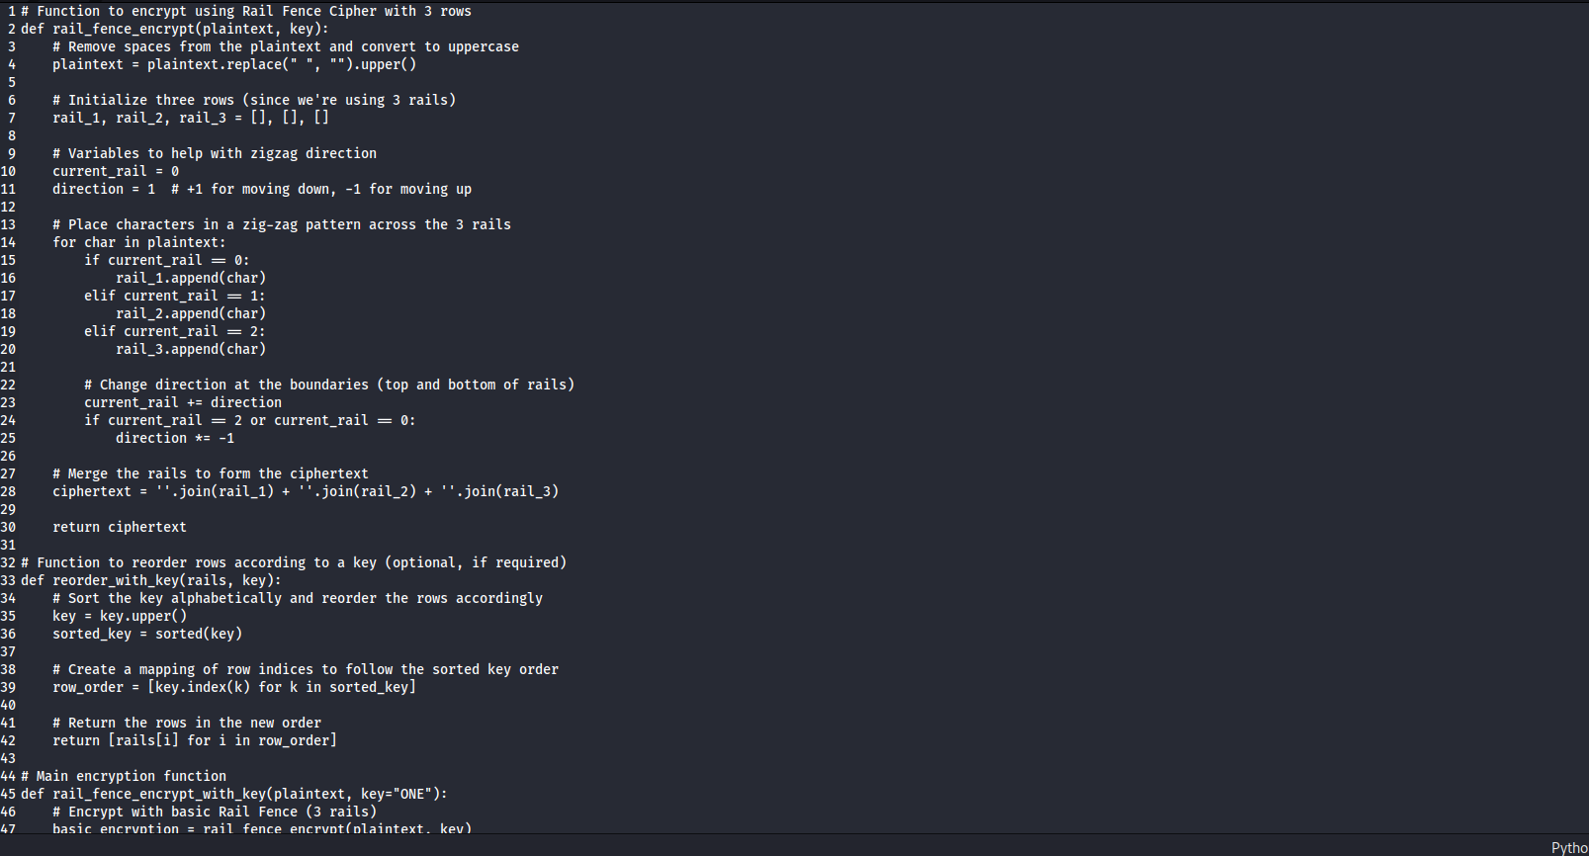

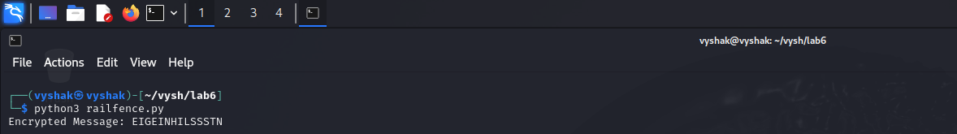

Write a python script to encrypt columnar transposition

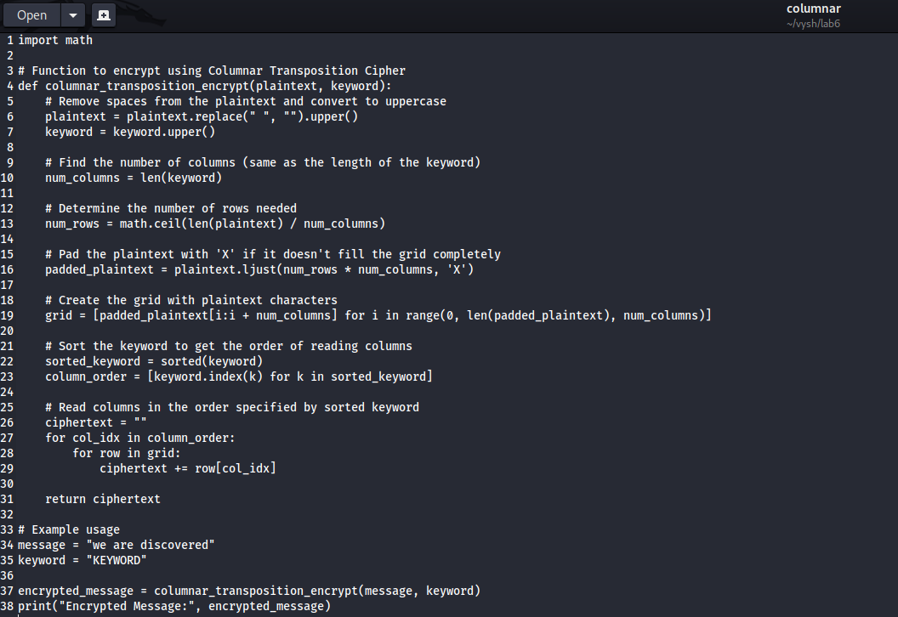

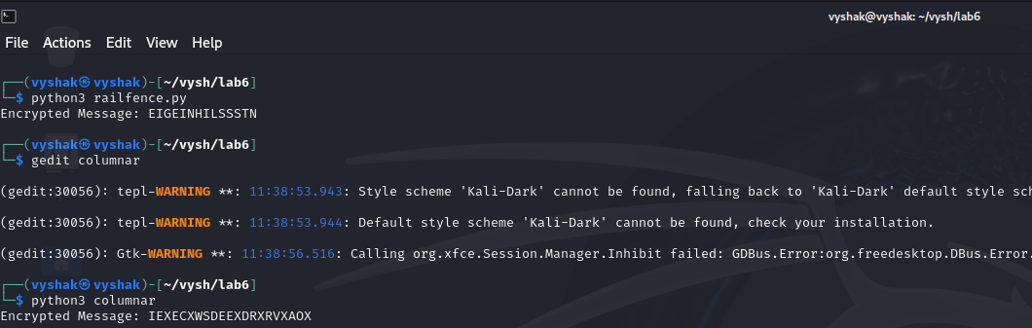

Write a Python script to decrypt Rail Fence Cipher.

